RADAR simulation
Written by: Yonathan Nativ

Preview 2
Quick start 2
Details 2
Professor comments 2
Main Files & Functions 3
The Radar Simulation GUI 4
Main RADAR display 5
Radar Controls 6
Simulation Controls 7

Preview
I made this simulation as a project in a course I took in RADAR basic concepts.
The RADAR is an Early Warning RADAR. The simulation simulates targets around the RADAR, calculates the expected return pulses and adds noise. The simulation works at the Intermediate Frequency (IF) level and I assume perfect phase reconstruction by the RADAR.

Quick start
- Run "radarSimulation.m".
- Press “Start”.

Details
It is a simulation of an early warning radar. The simulation generates random targets (coordinates, velocity, acceleration & Radar Cross Section (RCS)).
For each radar pulse the simulation calculates the returns that the radar will receive from all the targets according to the radar formula (taking into account transmission power, antenna gain, targets distance & targets RCS). The simulation calculates the amplitude & phase of the return signal (according to the IF frequency).
The radar builds a vector of its samples as complex signals (representing amplitude and phase delay) and adds it to complex random RF noise. The vector goes through a LPF representing the receiver BW and then I add another complex random noise representing the radar's thermal noise (in the digitizer).
The radar saves several reception periods to a buffer and then processes the entire buffer. The radar can perform a match filter over the received signal. The radar analyzes each range cell in the buffer in search of a target.
Detection threshold can be fixed or dynamic according to the buffer statistics (a sort of Constant False Alarm Rate (CFAR)).
In case Moving Target Indicator (MTI) is used the target detection is done in the frequency plane of the complex signal.
Each detected target is plotted on the main radar display. In case MTI is used a representation of the target’s velocity is also plotted (stationery targets are plotted as mountains). Take notice that the radar can only estimate the relative velocity between the target and the radar (any tangent velocity is lost).
Professor comments
My professor had several remarks about how bad this simulation is (the remarks were made on the previous version; I worked to correct some of them in this version). His remarks where:
- My match filter isn't really matched (it's true I matched it to square pulse and not to a band limited pulse).
- My noise levels have wrong units and aren't realistic (it might be true but you can control it as you wish so it isn't a real problem).
- Moving Target Indicator doesn't work the way I implemented it (might be true but I think my way is really good).
- The CFAR mechanism doesn't exist (yep I got sloppy but you can easily control the threshold so it's good enough and it is still just a simulation for a very small course!).
Changes in this Version
- Match filter was corrected (matches the real pulse shape).
- MTI works in frequency domain.
- A simple CFAR mechanism was added (really improves performance).
- Stagger support was added.
- Persistency display was added (detected targets stay on the display – revealing target’s path).
- Semi Analog feedbacks were added (audio & video).
- Targets maneuvers behavior was changed (still not perfect though).
- Massive profiler work was done to improve real-time performance (in 50 kHz sampling rate & no analog feedback the simulation time is correlated to real-time).

Though I think the noise generating mechanism is still not very realistic.

Main Files & Functions
- radarSimulation.m – GUIDE file, handles all the GUI callbacks.
The simulation is handled in “run_Callback” function.
- runRadarSim_v2.m – Main simulation handling function. Basically this function is a while loop which keep transmitting pulses and processing them. The function main parts are transmitting, adding noise & processing the radar buffer.

The Radar Simulation GUI

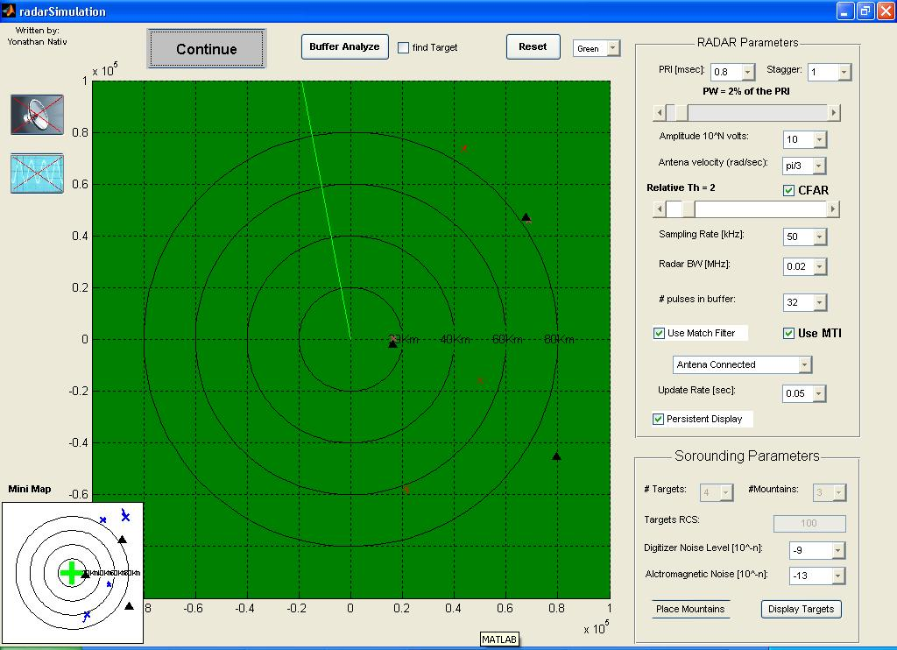
1
2
3
4
5
6

- Main Simulation Controls
  - Start\Pause\Continue – Starts and stops the simulation
  - Buffer Analyze – Collects pulses into the radar buffer and then stops the simulation to display the buffer content in separate graphs. In case the “find target” is checked the simulation will only stop when it will find a target in the buffer.
  - Reset – Resets all the simulation parameters (sets time back to zero and deletes all existing targets, new simulation targets are created on “Start”).
- Mini Display – Displays real position of the simulation targets (for reference).
- The main radar controls (see bellow).
- The main simulation controls (see bellow).
- The main radar display (see bellow).
- Analog controls – Activates the analog sound feedback and the scope display (slows the simulation real time performance).

Main RADAR display
2
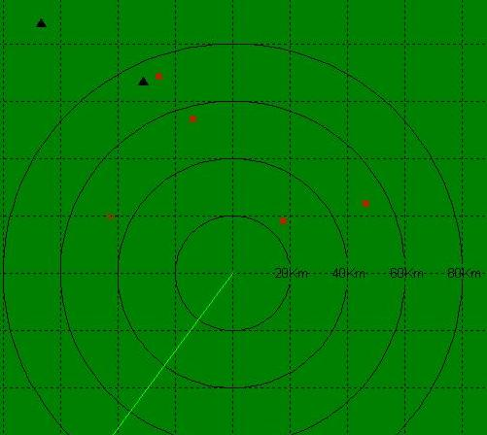
1

- The radar found targets.
  - Red X - target with no velocity estimation (MTI is off)
  - Red Arrow – a moving target with velocity estimation.
  - Black Triangle – a stationary target (clutter).
- The antenna point of direction.

Radar Controls
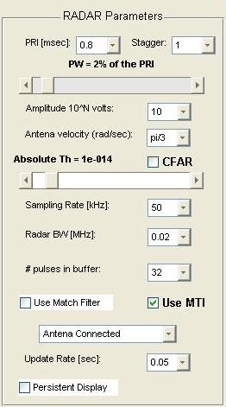
1
4
5
6
8
2
3
10
7
9
11
12
13

- Pulse Repetition Interval and the number of different intervals used (stagger). The PRI is the average time spent between each radar pulse transmission. The PRI defines the radar maximum range and the overall energy hitting a target.
- Pulse Width – defined as a fraction of the PRI and sets the transmission duty cycle.
- Transmitted Amplitude – The radar transmission power.
- Antenna Velocity – The antenna turn velocity in radians.
- Detection Threshold – works in Constant False Alarm Rate (threshold is set relative to reception level) or with a fixed threshold level. In both modes you can change the scroll bar to achieve the desired sensitivity level (it’s good to be a little in the noise level).
- The radar sampling rate – Defines the radar range cell size and directly affects the simulation real-time performance.
- Radar Band Width – The reception Band Width, determines the shape of the received signal and the amount of electromagnetic noise in the receiver.
- Number of pulses in the radar’s buffer, the radar analyzes reception every # of pulses.
- Moving Target Indicator – Activate phase analysis in frequency plane to distinguish moving targets from stationary ones (and estimate its relative velocity to the radar).
- Use a Match filter on received signal.
- Which type of antenna is connected (disconnect the antenna to estimate the digitizer noise).
- The radar displays update time.
- When using Persistent display previous detected targets are not erased from the radar display (helps tracking the planes path).

Simulation Controls
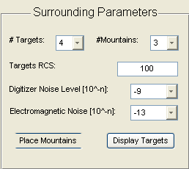
3
1
4
2
5

- Controlling the simulation targets. The targets are created randomly on “Start”.
  - # Targets – The number of aircrafts the simulation will create
  - # Mountains – The number of mountains (clutter) the simulation will create.
- The average Radar Cross Section of the aircrafts.
- The noise level simulated in the system. This is a normal distribution noise. The RF noise is multiplied by the radar BW and added before the applying of the BW. Digitizer noise is added after the BW (I’m not sure the noise model is that accurate…).
- Place Mountains – Enables you to place mountains in the simulation, click on the main radar display to place the mountains, when finished repress the “Place Mountains”. These mountains will be added to the simulation targets.
- Display Targets – Opens a separate figure displaying the real position o the simulation targets.

